* 1. **Some Hardware That Are Used in C-130E/B Aircrafts**
     1. **ISIS (Integrated Stanby Instrument System)**

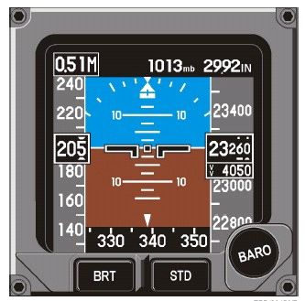

***Figure - 2 : ISIS***

ISIS shows ADI, attitude, air speed, altimeter, heading and ROC

* + 1. **MFD (Multi Functional Display)**

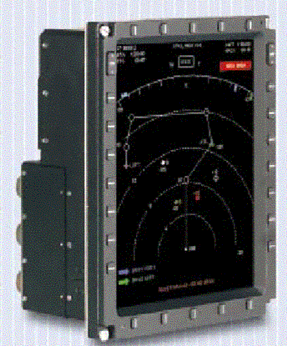

***Figure - 3 : MFD***

MFDs are in the shape of active matrix liquid crystal display. In each aircraft, there are 4 MFDs, 2 for the 1. Pilot and 2 for the 2. Pilot.

* + 1. **EIDS (Engine Instrumentation Display System)**

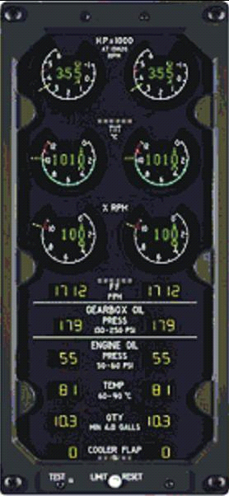

***Figure - 4 : EIDS***

There are 2 EIDS in each aircraft. Each EIDS shows the information about the 2 engines.

* + 1. **Radar System**

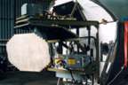

***Figure - 6 : Radar System***

There is 1 set radar system in each aircraft.

* + 1. **CDU (Cockpit Display Unit)**

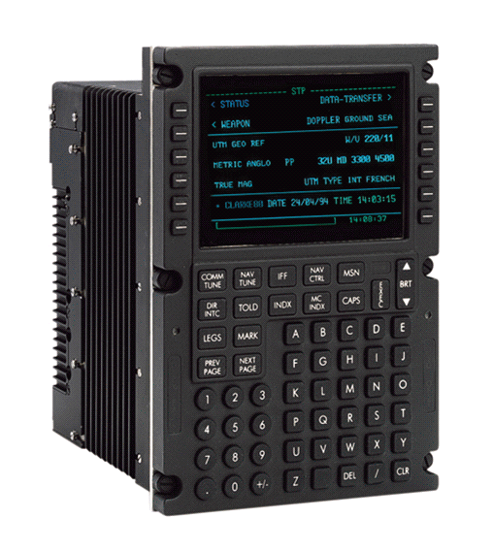

***Figure - 5 : CDU***

Flight team can do data entrance, flight management function control, sub-system control and system information watching through the CDU.

* + 1. **TACAN (Tactical Air Navigation)**

TACAN is the navigation system that is used in the military aircrafts. The control of TACANs is done through the control panel and the signals that TACANs received by using their antennas are showed on the MFD screen. There are 2 TACAN systems in each aircraft.

* + 1. **T ²CAS (Terrain Traffic Collision Avoidance System)**



***Figure - 7 : T ²CAS***

There is 1 set T ²CAS in each aircraft.T ²CAS shows distance, height and movement information on the MFD screen gives warnings to the flight team about the current situation.

* + 1. **VOR System (VHF Omni Range)**

Protects ILS from the radios that broadcasts in high power FM frequencies. System control is done by CDUs.

* + 1. **ADS (Air Data System)**

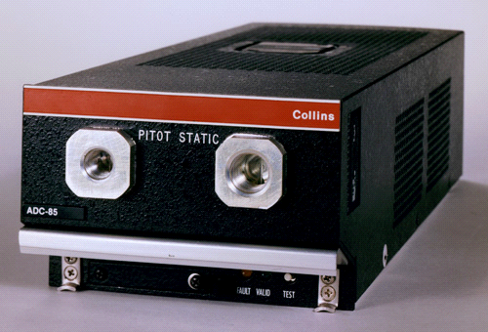

***Figure - 8 : ADS***

ADS provides the all data packages about the flight.

* + 1. **Radalt (Radar Altimeter)**

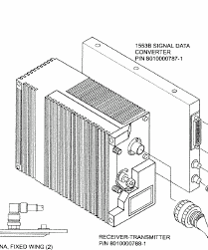

***Figure - 9 : Radalt***

Altitude information that comes from Radar Altimeter is passed to CCC and CCC produces “Low Altitude Warning” by using this information.

* + 1. **ADF (Automatic Direction Finder)**

ADF System control is done by CDUs. There are 2 ADFs in each aircraft.

* + 1. **EGI (Embedded GPS/INS)**

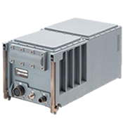

***Figure - 10 : EGI***

EGI is the unit that produces data that the aircraft needs to do some functions. EGI provides acceleration, velocity, position, magnetic north data and time data.

* + 1. **FDR/DCVR (Digital Flight Data Recorder/ Digital Cockpit Voice Recorder)**

Voice recorder system saves the talks of flight team in the cockpit.

* + 1. **AHRS (Attitude Heading Reference System)**

AHRS provides digital and analog direction information and angular velocity data.

* + 1. **V/UHF Radio**

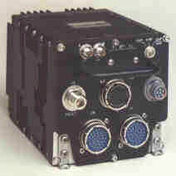

***Figure - 11 : V/UHF Radio***

VHF and UHF radios makes air-to-air communication, air-to-land communication and land-to-land communication possible.

* + 1. **DTS (Data Transfer System)**

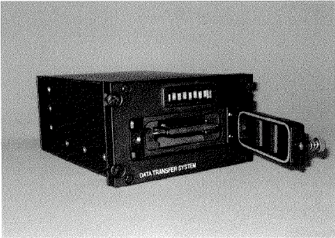

***Figure - 12 : DTS***

Information is stored in DTS by using Compact Flash Cards.

* + 1. **AFCS (Automatic Flight Control System)**

AFCS consists of a Flight Control Computer (FCC) that can make the aircraft fly automatically according to VOR1, VOR2, TACAN1, TACAN2 and FMS or according to height, velocity, direction functions.

* + 1. **CCC (Central Control Computer)**

The CCC is the integrator of the ERCİYES Avionics System. Act as 1553B Bus Controller. Receive all sensor data and perform the Navigation computations, with the best available data. Communicate with the Cockpit Display Unit (CDU) in order to enable manual data entry. Operate according to OSS functions on the CMFDs. Generate the symbology layer for the Color Multi Function Displays (CMFDs). Provide the mixing Video sources with symbology and video switching capability of all video sources. Interface with all Avionics Sub-Systems.